Melody

Observations and Playtester Comments

# In-Game Observations

[Your thoughts as you watch the testers play]

* Still very smooth
* Same as last playtest

# In-Game Questions

Why did you make that choice? (why go into houses?)

* Because they looked interesting

Does that rule seem confusing? (did increasing your stats seem confusing?)

* Not confusing

What did you think that would do? (what did you think interacting with people would do)

* Talking to them and increase states

What is confusing for you?

* no

# Postgame Questions

[Questions you ask the testers as they have played]

* why did you feel like you needed to talk to everyone?
  + Just made sense to see what everyone had to say
* Did making that person talk to you in the beginning set you up well for the rest of the game?
  + Yes, she provided more backstory that I needed

## General Questions

What was your ﬁrst impression?

* It was cute

How did that impression change as you played?

* It became cuter

Was there anything you found frustrating?

* The sudden bunch of texts, can be offputting

Did the game drag at any point?

* When I had to read too much

Were there particular aspects that you found satisfying?

* The art

What was the most exciting moment in the game?

* The bunny

Did the game feel too long, too short, or just about right?

* Just right

## Formal Elements

Describe the objective of the game.

* Increase stats

Was the objective clear at all times?

* Pretty much

What types of choices did you make during the game?

* Follow the road, go into houses, talk to people

What was the most important decision you made?

* Pretend I have empathy to increase my stats

What was your strategy for winning?

* Pretend I have empathy

Did you ﬁnd any loopholes in the system?

* no

How would you describe the conﬂict?

* There’s no backstory so not clear

In what way did you interact with other players?

* NA

Do you prefer to play alone or with human opponents?

* Depends on the game, don’t mind doing this one alone

What elements do you think could be improved?

* Text visually

## Dramatic Elements

Was the game’s premise appealing to you?

* Interesting to walk around, so yes

Did the story enhance or detract from the game?

* The story is the whole game

As you played, did the story evolve with the game?

* yes

Is this game appropriate for the target audience?

* yes

On a piece of paper, graph your emotional involvement over the course of the game.

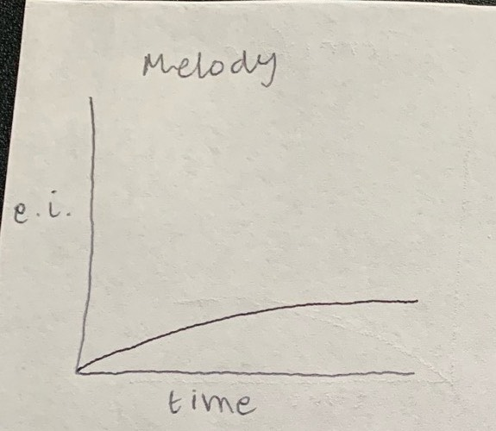

Did you feel a sense of dramatic climax as the game progressed?

* no

How would you make the story and game work better as a whole?

* The dialogue can be shorter and more succinct (more banter rather than reading)

## Procedures, rules, interface, and controls

Were the procedures and rules easy to understand?

* Yes, increase stats

How did the controls feel? Did they make sense?

* Felt good, made sense

Could you ﬁnd the information you needed on the interface?

* yes

Was there anything about the interface you would change?

* no

Did anything feel clunky, awkward, or confusing?

* no

Are there any controls or interface features you would like to see added?

* nah

## End of Session

Overall, how would you describe this game’s appeal?

* Good music, good visuals

Would you purchase this game?

* For $1

What was missing from the game?

* Less text, and an ending

If you could change just one thing, what would it be?

* text

Who do you think is the target audience for this game?

* kids

If you were to give this game as a gift, who would you give it to?

* My sister so she could suffer too

# Revision Ideas

[Ideas you have for improving the game]

* More banter within the game rather than throwing text at you